**Project Planning Phase**

**Project Planning Template (Product Backlog, Sprint Planning, Stories, Story points)**

**Product Backlog, Sprint Schedule, and Estimation (4 Marks)**

Use the below template to create product backlog and sprint schedule

Use the below template to list all the user stories for the product.

| **User Type** | **Functional Requirement (Epic)** | **User Story Number** | **User Story / Task** | **Acceptance criteria** | **Priority** | **Release** |
| --- | --- | --- | --- | --- | --- | --- |
| Customer (Web user) | Registration | USN-1 | As a user, I can register for the application by entering my email and confirming my password. | I can access my account/dashboard | High | Sprint-1 |
|  |  | USN-2 | As a user, I will receive a confirmation email once I have registered for the application. | I can receive a confirmation email & click confirm | High | Sprint-1 |
|  |  | USN-3 | As a user, I can register for the application through Gmail. | I can automatically move on to the dashboard | Medium | Sprint-1 |
|  | Login | USN-4 | As a user, I can log into the application by entering my email & password. | I can access the dashboard | High | Sprint-1 |
|  |  | USN-5 | As a user, I can reset my password if I have forgotten my password | I can reset my password again. | Medium | Sprint-1 |
|  | My Account | USN-6 | As a user, I can view my personal information | I can view my details | High | Sprint-1 |
|  |  | USN-7 | As a user, I can edit my profile photo | I can view my profile photo | Medium | Sprint-2 |
|  |  | USN-8 | As a user, I can edit my email I will receive the confirmation email to my new email address | I can change my email address | Low | Sprint-1 |
|  |  | USN-9 | As a user, I can log out of the application from my account | I can exit my account | High | Sprint-1 |
| Customer Care Executive | Dashboard | USN-1 | As a user, I want to upload an image to get a food analyzing | I can get my nutritious chart | High | Sprint-1 |
|  | Food Analyzer | USN-2 | As a user, I can select dishes and quantity from the option | I can choose from options or specific dishes. | High | Sprint-2 |
|  |  | USN-3 | As a user, I can view calories | I can check my nutrition chart | High | Sprint-2 |
|  | Work out | USN-4 | As a user, I can select my schedule | I can get my desired workouts and set times that fit my routine | Medium | Sprint-2 |
|  |  | USN-5 | As a user, I can select my specific short workouts |  | Hight | Sprint-2 |
|  | Reminder | USN-6 | As a user, I can get my daily remainder | I can get my daily schedule | High | Sprint-2 |
|  |  | USN-7 | As a user, I can get selected reminders for specific tasks. | I can set reminders for water, workouts, medicine and meals. | Medium | Sprint-2 |
|  | Plans | USN-8 | As a user, I can get diet and fitness plan | I can get my customized diet and workout plan | High | Sprint-3 |
|  | Tracker | USN-9 | As a user, I can track my health | I can get my track of calories, medicine, and sleep. | High | Sprint-3 |
|  |  | USN-10 | As a user, I can select what to track. | I can get my track of calories, medicine, and sleep. | High | Sprint-3 |
|  |  | USN-11 | As a user, I can customize my tracker | I can set my own tracker | meduim | Sprint-3 |
|  | Chatbot | USN-12 | As a user, I can have chatbot assistance for quick response. | I can have question and answer section | Medium | Sprint-3 |
|  |  | USN-13 | As a user, I can read blogs and discussions about my query | I can have access to my related blogs and discussion about it | Medium | Sprint-4 |
|  |  | USN-14 | As a user, I can discussions about my query | I can post as verified user. | Medium | Sprint-4 |
| Administrator | Login | USN-1 | As an admin, I can log in and out | I can access the dashboard | High | Sprint-4 |
|  | Dashboard | USN-2 | As an admin, I have a feedback form from my customer. | I can have my ups and down in my review session | High | Sprint-4 |
|  |  | USN-3 | I can view a graph and report on the most used features | I can access and modify the reports and graphs. | Medium | Sprint-4 |
|  |  | USN-4 | As an admin, I can view how many customers use the application | I can view how users are interested in it | Medium | Sprint -4 |

**Project Tracker, Velocity & Burndown Chart: (4 Marks)**

| **Sprint** | **Total Story Points** | **Duration** | **Sprint Start Date** | **Sprint End Date (Planned)** | **Story Points Completed (as on Planned End Date)** | **Sprint Release Date (Actual)** |
| --- | --- | --- | --- | --- | --- | --- |
| Sprint-1 | 20 | 6 Days | 24 Oct 2022 | 29 Oct 2022 | 20 | 29 Oct 2022 |
| Sprint-2 | 34 | 6 Days | 31 Oct 2022 | 05 Nov 2022 | 30 | 05 Nov 2022 |
| Sprint-3 | 60 | 6 Days | 07 Nov 2022 | 12 Nov 2022 | 60 | 12 Nov 2022 |
| Sprint-4 | 40 | 6 Days | 14 Nov 2022 | 19 Nov 2022 | 40 | 19 Nov 2022 |

**Velocity:**

Imagine we have a 10-day sprint duration, and the velocity of the team is 20 (points per sprint). Let’s calculate the team’s average velocity (AV) per iteration unit (story points per day)



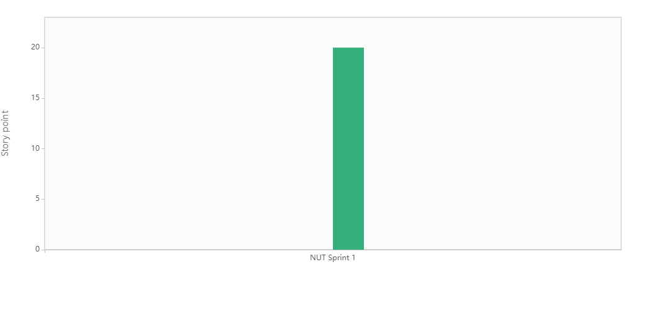

**Burndown Chart:**

A burn down chart is a graphical representation of work left to do versus time. It is often used in agile[software development](https://www.visual-paradigm.com/scrum/what-is-agile-software-development/) methodologies such as [Scrum](https://www.visual-paradigm.com/scrum/scrum-in-3-minutes/). However, burn down charts can be applied to any project containing measurable progress over time.

